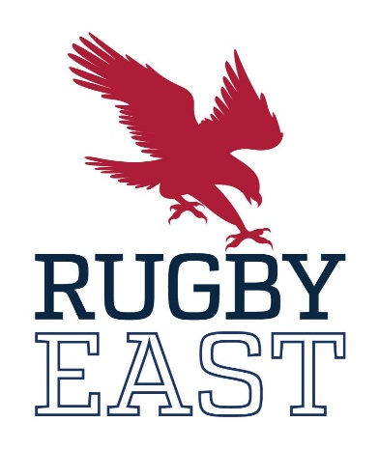
All Conference 2021-2022

First Team
1 | John O'Toole | Penn State
2 | Matt Meehan | Army
3 | Larry Williams | Army
4 | Drew Dunham | Army
5 | Collin Grosse | Army
6 | Ben Haugh | Navy
7 | Collin Brennan | Navy
8 | Jack McMahon | Navy
9 | Tai Kauwe | Kutztown
10 | Sean McNulty | Army
11 | Brian Stella | Penn State
12 | Keelin Coyle | St. Bonaventure
13 | Lucas Otineru | St. Bonaventure
14 | Dale Sturdifan | Navy
15 | Eddie Howell | Navy

Second Team
1 | Ethan Doumbe | St. Bonaventure
2 | Sai Fautanu | Navy
3 | Juan Pen | St. Bonaventure
4 | Peter Ratnayake | Navy
5 | Cameron Mills | Notre Dame College
6 | Koi Koi Nelligan | Army
7 | Steven Rohde | Army
8 | Lucas Pattinson | Army
9 | Tiaan Mosconi | Army
10 | Dalton Musselman | Penn State
11 | Nolan Green | Army
12 | Frank Bell | Navy
13 | Jesse Capriotti | Penn State
14 | Mike Amberg | Army
15 | Alex Chura | St. Bonaventure

Honorable Mention
1 | Isaac Marret | Army
2 | Janniel Badeas | St. Bonaventure
3 | Noah Smith | Penn State
4 | Cameron Thurtell | Kutztown
5 | Charlie Overton | Penn State
6 | Cory Ratka | St. Bonaventure
7 | Aidan King | Penn State
8 | Hugh Johnston | Notre Dame College
9 | Sebastiano Villani | St. Bonaventure
10 | Thorne O'Connell | Kutztown
11 | Fadzai Mushonga | Notre Dame College
12 | Greg Steffens | St. Bonaventure
13 | Jackson Aleman | Navy
14 | Mate Kvirikashvili | Kutztown
15 | Lewis Gray | Navy

